At this stage, I did select topics by analyzing the priorities set by the EUROfusion group in charge of the ITER operation (cf table 1) and the list of high priority items to support ITER engineering design as set by A. Becoulet (as Head of Engineering domain). I try to find topics that are of join interest between EUROfusion and ITER-IO to maximize the chances for a young engineer to get a future position within either the EU beneficiaries or ITER-IO or F4E. Not all the topics are for WPrIO. The list below of proposed topics for EEG is not prioritized. At the moment ITER potential contacts have not been contacted.

Topics
- Development of a wall monitoring system for real time protection of the plasma facing components in support to ITER operation
  - This is a high priority topic for ITER and EUROfusion. An activity has been initiated within WPrIO and should have a critical impact to support ITER operation since the development of reliable ITER scenario will require real time protection of PFC while optimizing the fusion performance.
  - Subject already elaborated in 2020 cf annex to this document
  - This is of join interest for PrIO, W7X and PWIE and TE
  - ITER Contact R. Pitts
- Engineering support on the wall conditioning and ITER Glow Discharge Cleaning design
  - Within WPRIO, the sub-project called ITER operation will have a strong focus on the first plasmas operation items. One item identified with ITER-IO is the wall conditioning aspects and the lessons leant from the EU tokamaks. This is of join interest for ITER and EUROfusion. The work will impact the first plasma operation phases where we expect already significant EU participation.
  - This is of join interest for PrIO, and PWIE and TE
  - ITER contact: So MARUYAMA , R . Pitts
- Efficiency optimization of negative ion beams for ITER Neutral Beam Injector prototypes (NBTF)
  - Within WPRIO, a strong effort is made to support ITER for a safe operation of the NB systems. This is a strong priority in EU with the exploitation of the NBTF. The young engineering will join a team at the NBTF and should be in a good position to be part of the NB system operation in the long terms.
  - Subject already elaborated in 2020 cf annex to this document
  - PrIO
  - ITER NBTF contact: vanni.toigo@igi.cnr.it
- Reduction of co-extracted electron currents and improvement of their symmetry in large negative ion sources for ITER NBI
  - Within WPRIO, a strong effort is made to support ITER for a safe operation of the NB systems. This is a strong priority in EU with the exploitation of the NBTF. Co-extracted electrons are limiting the performance of the beam source in Deuterium; identification of measures are of utmost relevance for the success of ITER NBI in D and DT phases.
  - The young engineer will join a team at IPP and will learn operation of the test facility ELISE with focus on Deuterium beams.
  - The person should be in a good position to be part of the NB system operation in the long terms.
  - PrIO
  - IPP contact : Ursel Fantz, ursel.fantz@ipp.mpg.de
- Neutron calibration System: development of neutron sources , I&C and software
  - Based on the experience acquired from JET DT calibration (the support to ITER calibration is topic we would propose in Prio).
  - The possibility to promote an engineering grant could strengthen the contribution of EUROfusion on ITER site and help for training young people!
  - PrIO
  - ITER Contact M. Merola
- Diagnostic Tritium Monitor: development of the LIBS system for JET and ITER
  - If JET is extended beyond 2021 a major enhancement is the LIBS system. In addition this system is of high importance for ITER future tritium operation.
  - Mainly PWIE and TE-JET

Table 1 WG’s recommendations on “EUROfusion role in ITER operation and scientific exploitation”

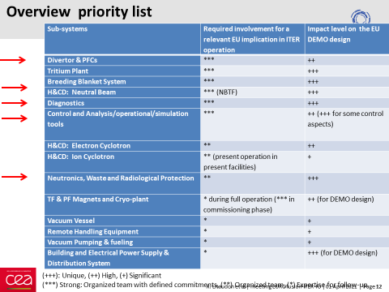

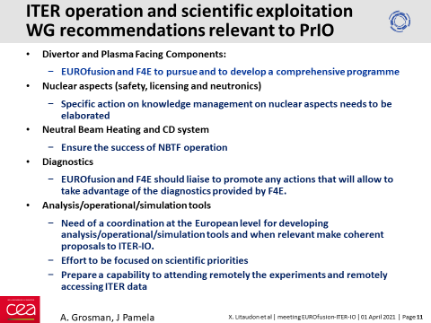

Table 2 : ITER priority in the Engineering domain

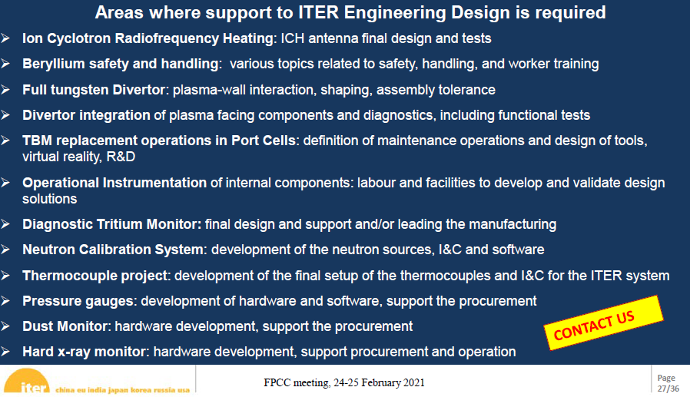

WPPRIO Efficiency optimization of negative ion beams for ITER Neutral Beam Injector prototypes
Position ref. EEG-202x/xx
Contact person: G. Chitarin - giuseppe.chitarin@igi.cnr.it G. Serianni - gianluigi.serianni@igi.cnr.it
Job Description
The goal of the Grant is to train an MS or PhD graduate to become a professional in the engineering and energy efficiency aspects of Neutral Beam Injectors (NBI).
In the medium and long term such experience will be greatly valuable in the exploitation of the ITER Neutral Beam Test Facility (NBTF, including the SPIDER and MITICA experiments), in Padua (Italy), and in the operation of the ITER experiment itself in Cadarache (France).
Neutral beam injection is one of the main heating and current drive mechanisms for future fusion devices. On ITER two beamlines based on large negative ion sources will be installed, and are designed to deliver a heating power of 16.7 MW each. Negative ions (H-/D-) will be accelerated up to 1 MeV, neutralized and injected into the torus for a duration up to 1 h.
Negative ions are produced inside a source driven by Radio Frequency Coils and are accelerated through a multi-aperture and multi-stage acceleration grid system, up to the nominal energy (about 100 keV in SPIDER and 1MeV in MITICA).
In view of operation in ITER, efficiency of NBIs can be improved in several aspects of NBIs. The foreseen optimization objectives in NBI efficiency are:
- optimized ion source operation and conditioning procedure, magnetic field configuration and Caesium distribution system, allowing increased generation of negative ions particularly in long-pulse operation as required for ITER NBIs
- enhanced control of the background gas pressure in the accelerator, with decreased loss of negative ion current caused by stripping reactions inside the accelerator, smaller production of secondaries and therefore reduced heat load deposition onto the accelerator grids,. This is also particularly relevant for long accelerators like the one featured by ITER NBIs
- avoidance of interception of beam edges on the surfaces of beam line component (neutraliser and residual ion dump) and prevention of further production of ions (caused by interaction of beam with background gas) which can affect the distribution of electric fields inside the residual ion dump.
The Grantee’s activity will focus on the engineering design, realization and operational aspects of the phenomena and components affecting the overall NBI efficiency. The aforementioned aspects will be addressed for the source, the accelerator and the beam drift region.
The Grantee will participate to experiments in NBTF and other collaborating labs and initially use and improve existing numerical models or develop new ones for interpreting the results and conceiving and evaluating novel solutions for the enhancement of the NBI efficiency.
Suitable caesium distribution systems and techniques, acceleration voltage profiles, vacuum and pumping techniques will be identified during the work.
In a second phase, the Grantee will propose and perform relevant experimental tests or will improve and operate relevant diagnostics. The experimental results will be obtained by measurements in SPIDER and in other experiments, thanks to the ongoing collaborations with external laboratories. The whole activity will then represent a necessary input for MITICA, where operations will start in 2023.
The Grantee will be integrated in the NBTF team. In collaboration with his/her colleagues, he will be trained on the operation and characterization of NBI sources and their parameters. With the team, he will develop correlation of the beam features with the parameters of the various plants: caesium evaporators, accelerator power supplies, vacuum plant and diagnostics.
The Grantee will be introduced to the existing devices and modelling tools as well as to the ongoing design and procurement activities and will work in a team of skilled engineers, physicists and technicians at the ITER NBTF.
Eligibility: Master degree in Engineering or Physics discipline; PhD or multi-year (including the Master period) experience in the field of negative ion accelerators. Preference will be given to applicants with experience in numerical simulation or design and operation of beam diagnostic systems. Experience in the design of sources and accelerators for ion beams will be an advantage.
EUROfusion Work Packages: Principal: WPPrIO Preparation of ITER Operation; Secondary: WPHCD Heating and Current Drive Systems.
Facilities to be used: Neutral Beam Test Facility in Padua, Italy (SPIDER and MITICA). Other facilities relevant for the activities could also be used.

WPPRIO Improvement of the beam and co-extracted electron symmetry for large negative ion sources of the ITER NBI

Position ref. EEG-2020/xx
Contact person: Ursel Fantz; ursel.fantz@ipp.mpg.de
Job Description:
On ITER two NBI beamlines with large radio–frequency driven ion sources (1 × 2 m²) will be installed, delivering a heating power of 16.7 MW each. Negative ions (H–/D–) are accelerated up to 1 MeV in a grid stack, neutralized and injected into the torus for up to 1 h. Along with the negative ions also electrons are co-extracted from the source. These are magnetically filtered out of the beam and dumped on the second grid. The resulting thermal load usually limits the operational space of these ion sources. Furthermore a magnetic filter field in front of the first grid is installed to cool down the ion source plasma in order to reduce the current of co-extracted electrons and to increase the extracted negative ion current. This filter field creates plasma drifts in the source and thus causes asymmetries in the plasma, the extracted ion beam (current and divergence) and the co-extracted electrons. The goal is to minimize these asymmetries ion order to achieve a uniform beam and avoid local thermal overloading of the second grid on which the electrons are dumped. Three strategies contribute to achieving this goal: (1) modifying the magnetic filter field topology in order to symmetrize the plasma (and thus the beam), (2) biasing surfaces close to the extraction system to symmetrize the extracted beam and/or co-extracted electrons (and lowering the latter), and (3) optimizing the aperture geometry of the first grid (which is strongly connected to the electron deflection magnetic field) for lower co-extracted electron current.
This EEG aims at training an engineer in NNBI ion source design in an area between mechanical engineering and ion source physics. The grantee will gain hands-on experience in the operation of the test facilities for the ITER NBI at IPP Garching, Germany, ELISE and BATMAN Upgrade. The activity will focus on the investigation of improving the beam symmetry and beam deflection as well as reducing and symmetrizing the co-extracted electron currents. The applicant’s contributions are expected to the modelling of magnetic field configurations (by FEM) as well as to the mechanical design of components for improvements.
The magnetic field maps will serve as input for further code simulations on plasma and beam uniformity (both not part of the grantee´s task) and modelling results will be correlated with the accelerated beam profile measurements and the asymmetry of co-extracted electrons for further optimization. Similar correlations should be carried out for improved biased surfaces close to the extraction system. The combination of modifications of the magnetic fields and biasing surfaces is a main topic of the upcoming experiments at the IPP test facilities in order to find an effective and also easy applicable solution for a safe ITER operation.
Furthermore the reduction of co-extracted electrons is strongly determined by the interplay between the electron deflection field—generated by permanent magnets imbedded into the grid—and the geometry of the apertures of the first grid. In combination with modelling and experiments performed at both test facilities, an optimum configuration shall be designed by the Grantee and experimentally confirmed.
The candidate will work in a team of skilled physicists, engineers and technicians and collaborations with colleagues from other institutes will be encouraged. The results gained should help to improve the source and extraction system for reliable negative ion beams on ITER.

Eligibility:
- Master’s degree in engineering or equivalent in a relevant discipline
- Excellent interpersonal, teamwork and communication skills, including a good level of spoken & written English

Preferable:
- Experience working in an international environment
- Experience in mecahnical engineering and FEM modelling

EUROfusion Work Packages involved:

Interlinks with other Work Packages:
Facilities to be used:

WP-7X Development of Infra-Red monitoring system using artificial intelligence techniques in view of ITER application

Job Description:

The EEG proposal is to develop a wall monitoring system for real time protection of the plasma facing components in support to ITER operation. The system will be implemented and validated on W7-X (IPP/Greifswald/GERMANY) and WEST (CEA/Cadarache/FRANCE) to provide safe and high performance steady-state long duration operation. Synergies of both institutes for this common objective lead to develop unique expertise and methods to prepare the ITER first wall protection.
The internal components inside present and future fusion experiments (ITER , DEMO) are exposed to large amount of power (~100MW) and energies and are designed to protect vacuum chamber of the machine from high fluxes coming from the confined thermonuclear plasma. The concentrated thermal load could exceed the limits set by the component's design, causing irreversible damages. To avoid such damages, the internal components are monitored during plasma operation using a set of infrared (IR) viewing system. Since human operators could not handle and process a large numbers of thermal events in real time operation, the development (including design, implementation and exploitation) of automated detection and analysis tools is an active domain of research in the context of the nuclear operation of ITER and future DEMO reactors [1-3]. W7-X and WEST teams have already joined their efforts on designing and building the infrared acquisition and data handling tools. There is a significant collaboration between the two EU teams, through the development and exploitation of ThermaVIP acquisition, visualisation and analysis softwares. Both groups share their new developments, where machine generic applications and routines developed for one machine are easily transferred to the other one before a future implementation on ITER.
This proposed EEG is for bringing the collaboration to the next step of development, by developing and implementing advanced data analysis techniques for the management of thermal events in both machines. The tools shall address the challenges of hotspots classification, including automatic detection of false positive and irrelevant hot spots, hot spot rating (criticality, urgency, relevance) by using techniques of artificial intelligence and machine learning (object detection & tracking, instance segmentation, expert system, fuzzy logics, deep learning, other…). The workflow will be designed with a system engineering approach, so that its relevance goes beyond the exploitation and validation on W7-X and WEST, and could be implemented in other magnetic fusion machines (JT-60SA, ITER, DEMO).
Complementing a broader attempt for a European framework in computer vision for wall protection, a tight collaboration with the proposal on video protection is envisaged.

[1] Thermal Event Recognition Applied to Protection of Tokamak Plasma-Facing Components, IEEE Transactions on Instrumentation and Measurement, Vol. 59, No. 5, May 2010, Vincent Martin, Jean-Marcel Travere, François Brémond,
[2] Infrared imaging systems for wall protection in the W7-X stellarator, Rev of Sci INstr. 89, 10E116 (2018), Marcin Jakubowski, Peter Drewelow, Joris Fellinger et Al.
[3] The JET real-time plasma-wall load monitoring system; Fusion Engineering and Design, Volume 89, Issue 3, March 2014, Pages 243-258, D. F. Valcárcel, D. Alves, P. Card, B. B. Carvalho, JET EFDA Contributors

Eligibility:
- Master degree in Engineering or equivalent in a relevant discipline
- Excellent interpersonal, teamwork and communication skills, including a good level of spoken & written English

Preferable:
- Experience working in an international environment

EUROfusion Work Packages involved: WPW7X

Interlinks with other Work Packages: WPPrIO, WPTE
Facilities to be used: WEST, W7-X, collaboration with ITER-CT

