Minutes kick-off meeting PWIE SP X3 08-07-2021
Present: Tom Wauters (LPP-ERM/KMS), Vladimir Moiseenko (KIPT), Per Petersson (VR), Sören Möller (FZJ), Tom Wauters on behalf of Fransisco Tabares (CIEMAT), Yurii Kovtun (KIPT), Michael Reinhard (FZJ)
The plans which were presented cover a 2 years period 2021-2022: intermediate reports will be prepared at the end of 2021 or beginning 2022.
Hennie
Hennie summarized the goals of the SP X3 project

Sören and Tom (Exploitation of TOMAS)
- Sören and his colleagues will work coming 2 weeks on mainly He based glow discharge and ECRH and ICRH plasma exposures in TOMAS to investigate removal effects of boron coated graphite and TEXTOR graphite. This will be followed up by post-mortem analysis.
- Diagnostic systems: RFA system for ion energy measurements is in preparation
- Plasma characterization ongoing
- Modelling: first ECRH plasma will be modelled including modelling of power absorption. It is complicated how waves propagate. Paper on this subject to be expected at the end of this year.
- ICRH absorption will be modelled in a second stage (Vladimir could contribute to this very well)
- Modelling of the particle propagation through plasma and ToF tube (>10-5 mbar significant influence on particle propagation) is in preparation
- Boron removal modelling will be performed next year 2022
One of the goals is to investigate the role of sputtering/chemical sputtering

Summary from the slides
Tasks for 2021
- Diagnostic/system upgrade : EC & IC / Probes / RFA (optional) Andrei + Riccardo, Sören …
- ECWC, ICWC, RF plasma characterisation in TOMAS Daniel, Johan, Laura, Per, Yurii …
- Modelling of TOMAS plasma, EC Johan
- Plasma-facing material cleaning in TOMAS : exposure of boron coated tiles to ICWC and GDC All
- Coordination of TOMAS experiments Tom and Andrei
- Surface analysis of boron coated samples Per, Sören

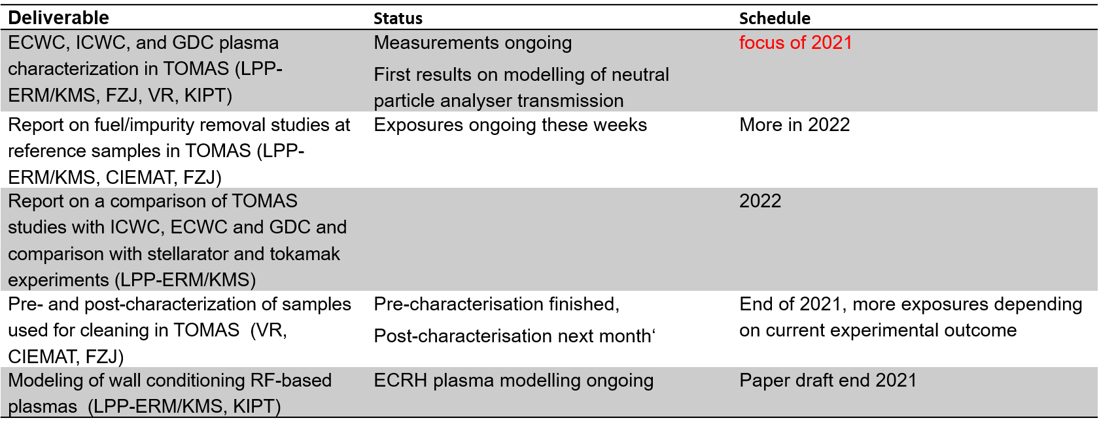
Per (Pre- and post characterization of samples and ECWC/ICWC/GDC plasma)
- Boron coatings from TEXTOR are pre-analyzed with ToF-NRA (after so many years still low D content could be found (chemical bonding?). These and also more pure boron coatings will be exposed in TOMAS to investigate B removal efficiency.
- Neutral energy distribution was measured with TOF diagnostic (NPA) in TOMAS

Francisco (pre- and post-mortem analyses and fuel/impurity removal studies)
- Pre and post analysis of TOMAS samples (not TJII)). Samples can be prepared and pre-analyzed at CIEMAT and installed in TOMAS followed by post-mortem analysis at CIEMAT.
- Paco proposed studying oxygen for Boron removal. While pure oxygen is not compatible with magnetic fusion devices, studying admixtures of helium or hydrogen with oxygen could be of interest. Small amounts of oxygen can be present in the background gas and materials of carbon devices but also in ITER. It is important to understand how these affect PWI.
- Application of in situ LIBS could be interesting for TOMAS

Yurii (diagnostics & plasma characterization)
- A classical single tip probe and a so-called triple probe (no voltage sweep required) were installed and the radial distribution of n_{e} and T_{e} was measured in TOMAS
- Coming period more measurements will be done, in case Yurii cannot join the measurement campaigns, a student of ERM with guidance from Yurii will perform the measurements

Vladimir (modelling)
- Vladimir developed a model for RF plasma in stellarators that includes a system of the particle and energy balance equations for the electrons and the boundary problem for Maxwell’s equations. This model will be tested for TOMAS
- A module developed by Vladimir that models the propagation of RF waves in the ICWC plasma is incorporated in the code run by Johan. The collaboration on this work will be renewed. For Johan, the priority for now is EC waves.

General risk for the project that can cause delays
In the near future, some people will leave the project and others will join, thus monitoring of continuity is a point of concern for avoiding too much delays.
Furthermore the impact of COVID could be still a risk for the progress of the project

