SP X2: Optimization of laser-based surface analysis diagnostics (2021)
Agenda meeting Thursday 15th of July
Everybody has the opportunity to give an overview of their activities, but please include in presentations how all tasks (given below) will be realized. Please include also the deliverables for 2021 and indicate the issues/problems you possibly expect to encounter
Time | Duration | Topic | Speaker
11:00 | 10 | Introduction:  - key points this year  - test samples for further research  - paper | Hennie, DIFFER
11:10 | 10 | Tasks and deliverables/issues | Antti, VTT
11:20 | 10 | ,, | Indrek, UT
11:30 | 10 | ,, | Elodie, CEA
11:40 | 10 | ,, | Jelena, LU
11:50 | 10 | ,, | Salvatore, ENEA
12:00 | 10 | ,, | Pawel, IPPLM
12:10 | 10 | ,, | Gennady, FZJ
12:20 | 10 | ,, | Pavel, CU
12:30 | 10 | Decisions/summary tasks and appointments for measurements paper
~12:40 |  | Closure

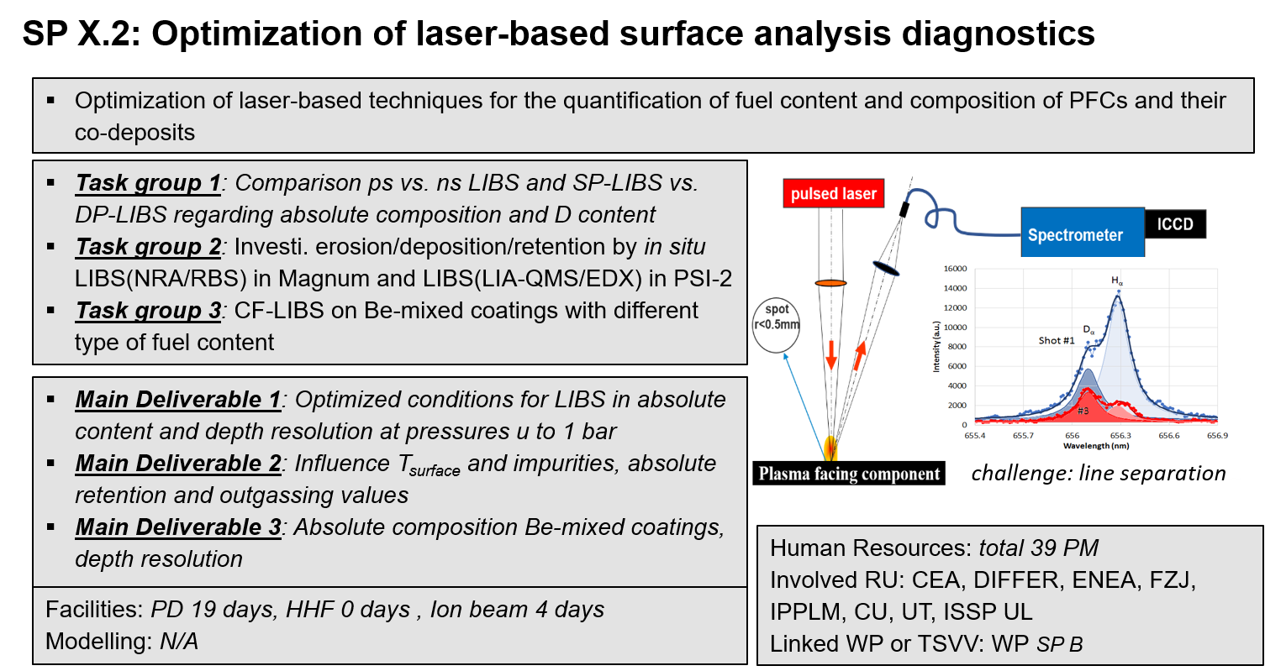
Here is a slide describing the main SP X2 goals for this year (from presentation Sebastijan at the Project Board held at June 22 2021

TASKS TO BE PERFORMED IN 2021
LIBS performance enhancement:
- Comparison ps vs. ns LIBS regarding absolute composition and D content in reference and ITER-relevant coatings which can include impurities (FZJ, CU, UT, ISSPUL, CEA)
- Comparison Single Puls vs. Double Puls LIBS (or alternative LIBS signal enhancement methods) regarding absolute material composition and D content in ITER- and DEMO-relevant W including self-damage W and reference coatings. (FZJ, ENEA, CEA)
- (CF-) LIBS (ps, ns SP or DP) on samples (if available) from different devices (tokamaks or W-7X) (collab. SP B) (ISSP UL, CU, UT, VTT, FZJ, ENEA)
- Improve LIBS analysis by application of machine learning algorithm (IPPLM)
- (CF-)LIBS on Be containing coatings with different type of fuel content (VTT, UT, CU)
- CF-LIBS on produced reference samples before and after He loading (FZJ, CU, UT, ENEA)
- Investigate erosion/deposition/fuel retention (including He) by in situ (CF)-LIBS and NRA/RBS in MAGNUM, LIBS and LIA-QMS/EDX in PSI-2 with subjects of interest: outgassing, recycling, and role of impurities (O, N), T_{surface}, and implantation energy on retention (DIFFER, FZJ, UT)

