EnR IDTT meeting February 2022-02-23

1-On the integration of the HFS antenna in the available space.

The original setup on the table for discussion reserves space for a tentative two bistatic systems, in the proposed design, one near the equatorial plane and a second in upper section of the machine.

Unfortunately, this design separates the Tx/Rx pair excessively, which almost certainly impairs the operation of the system.

It is paramount that a new solution/design/configuration for the antennas or to design a new antenna that fits in the available space. In discussion are different solutions to address the problem (see Figure 1)

- A monostatic setup. Using just one antenna will solve the size restrictions and guarantee the same line-of-sight in Tx/Rx. This is, nevertheless a difficult to implement due to the possible presence of multiple stray reflections in common RX/TX transmission line path that will mix and dim the plasma signal, reason for the preferred choice of a bistatic system. A further evaluation of this possibility needs to be carried out.

- A bistatic setup with “Up/Down” antennas. This solution permits a bistatic system with just one cooling pipe removed. The inverted antenna act as collector of debris and dust, which with time can lead to a deterioration of the system. Also, the waveguide routing of the inverted antenna ideally should be made by the lower part of the machine since routing the waveguide behind the remaining cooling pipes can be difficult and pose problems during a needed disassembly of the wall

- A bistatic setup with two adjacent cooling pipes removed. This is from the reflectometry point of view the best solution since it allows a bistatic system having the two antennas, Tx and Rx, side by side. It relies on the feasibility and authorization of having one more cooling pipe removed.

- A bistatic setup with two non-adjacent cooling pipes removed. Not as effective as solution b) but still a good compromise. As an advantage, the uncooled area is not continuous. Relies as well on the feasibility and authorization of having one more cooling pipe removed.

- A bistatic setup with a Tx/Rx “mono-bloc” antenna. This solution implies the design of a new antenna able to squeeze two antennas, for Tx and Rx in the same volume occupied by the original one. This new antenna will forcibly have a worse performance than the original one. Its design should minimize cross talk, which may occur, given the geometry and dimensions involved.

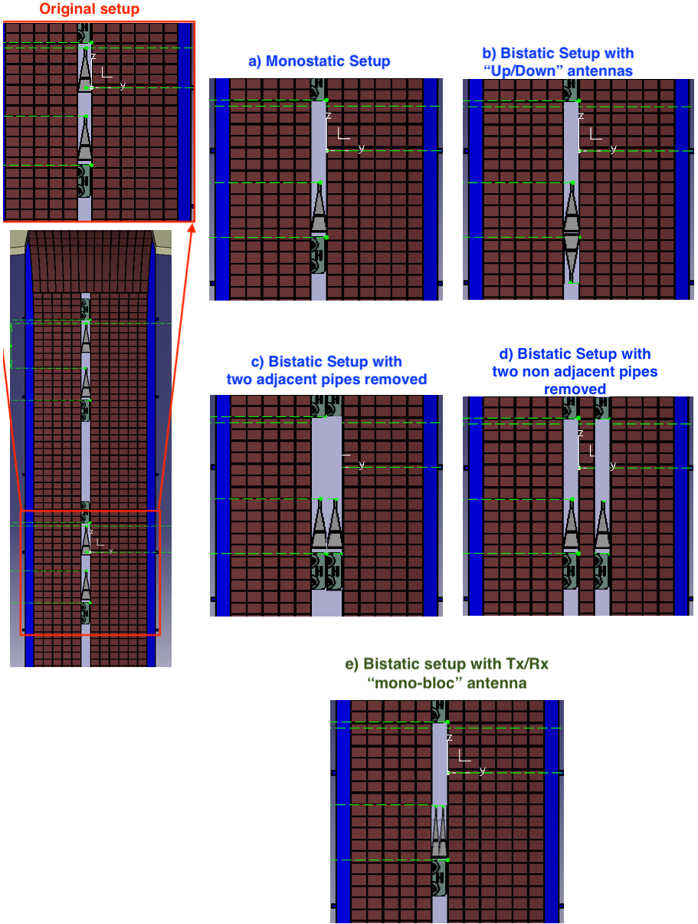
Figure 1 Possible solutions to have the transmission and reception close to each other.

Actions:

- Look into the possibility of having a monostatic system
- Investigate the possibility routing waveguides through the bottom of the vessel or routing them behind the cooling pipes
- Investigate the possibility of having an additional cooling pipe remove adjacent to the access already established.
- Investigate the possibility of having an additional cooling pipe remove non adjacent to the access already established.
- Design of a mono-bloc Tx/Rx antenna.

2-Density description of the steady state in the SOL or an approved model for it.
For steady state, an official equilibrium is available with densities up to the separatrix but we still need the density description outside the separatrix or a model for it.

Actions:
- Wait for a model of a density data description until ~11th of March.
- If a description/model is not made available follow with our own educated modelling effort, as performed in earlier simulation assessments.

3-Densities of the ramp-up phase to complement the equilibria already available.

For the ramp-up phase of a set of time evolving equilibria has been made available. Unfortunately no associated description for the densities is present. To follow with the simulations it is paramount to have them, inside and outside the separatrix, since the modelling of the ramp-up is an extremely important part of the Enabling Research project and further delays on these inputs will impact negatively.

Actions:
- Wait for a model of the densities until ~11th of March.
- Directly contact colleagues working on this topic that may supply the inputs or helping doing it, even if not the official ones.
- Establish, if 1. and 2. become dead ends, an educated guess/model from the equlibria descriptions, Pressure and Energy deposition.

