**How to contact and reach DIFFER**

**Get in touch**

* For general information about DIFFER's activities [info@differ.nl](mailto:info@differ.nl)  |  [+31 (0)40 333 49 99](tel:+31%20(0)40%20333%2049%2099)

**Addresses**

Visitor's address

Dutch Institute for Fundamental Energy Research   
TU/e Campus   
De Zaale 20   
5612 AJ Eindhoven   
The Netherlands

Postal address

Dutch Institute for Fundamental Energy Research   
P.O. Box 6336   
5600 HH Eindhoven   
The Netherlands

**How to reach DIFFER**

DIFFER is based at a [highly sustainable building](https://www.differ.nl/about-us/new-building) on the campus of Eindhoven University of Technology. We are located on the far east side of the campus of the Eindhoven University of Technology in the center of Eindhoven, at some fifteen minutes walking distance from Eindhoven railway station. [Plan your visit to us at De Zaale 20 in Eindhoven by public transport](http://9292.nl/en?to=eindhoven_de-zaale-20).

[Plan my journey on 9292](http://9292.nl/en?to=eindhoven_de-zaale-20)

**Disabled persons**

Our building is wheelchair accessible. There are two parking places for disabled people right in front of the main entrance of the DIFFER building.

**Public transport**

There are several bus stops in the area at a few minutes walking distance from the institute. Plan your bus trip from Eindhoven railway station with [9292](http://9292.nl/en?to=eindhoven_de-zaale-20).

**Coming by bike or car**

Parking and locking your bike is easy possible in front of our main entrance. Charging your **electric bike**? Please contact the DIFFER reception at the main entrance or by calling +31 40 3334 999 and discuss the possibilities.

For information about accessibility, route, parking, parking charges and a map, visit [Accessibility, route and map TU/e Campus](https://www.tue.nl/en/our-university/tue-campus) or [Parking on TU/e Science Park](https://www.tue.nl/en/our-university/tue-campus/accessibility).

**Maps**

To find all information you need to prepare your visit and trip, by public transport, bus line, bicycle, car or from Eindhoven Airport, please visit [Accessibility, route and map TU/e Campus](https://www.tue.nl/en/our-university/tue-campus). Check out a [map of the campus](https://www.differ.nl/sites/default/files/images/contact/TUe_DIFFER_Map_aug-2023.pdf) and the DIFFER building on [Google Maps](https://goo.gl/maps/kudUq).

[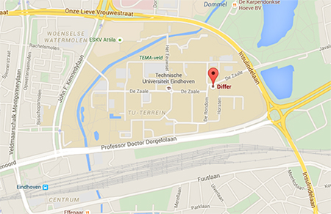](http://goo.gl/maps/kudUq)

**Hotel accommodation**

***NH Hotel Eindhoven***

Vestdijk 5, 5611 CA, Eindhoven

+31 (0)40 80 09 900

<https://www.nh-hotels.com/en/hotel/nh-collection-eindhoven-centre?utm_campaign=local-gmb&utm_medium=organic_search&utm_source=google_gmb>

Other options:

***The Social Hub***

Stationsweg 1, 5611 AA Eindhoven, Nederland

+31402319792

<https://www.thesocialhub.co/eindhoven/>

***Crown Hotel Eindhoven Centre***

Vestdijk 14-16, 5611 CC Eindhoven, Nederland

+31408444000

<https://www.crownhoteleindhoven.com/>