# 2024 TSVV-5 Annual Report from DIFFER

**Coupling of SOLPS-ITER with FreeFEM for the consistent modelling of target/wall elements**

The coupling of solps-iter with the FreeFEM [1] code for the consistent modelling of the temperature distribution in target or wall elements was revisited. The required workflow has been documented in detail for future reference [2] for the case of the simulation of the plasma in Magnum-PSI with a solid W-target as published in [3]. The basis for these simulations is formed by a standard solps-iter simulation of a Magnum-PSI high density case with a neutral pressure in the target chamber of 0.46 Pa as documented in detail in [4].

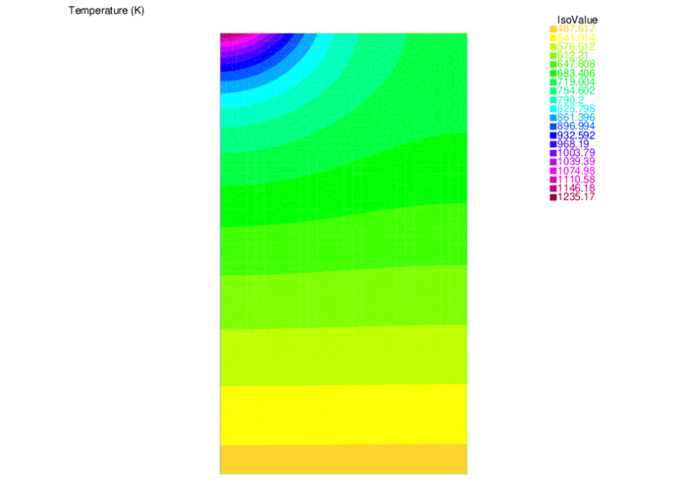

**Figure**: The temperature distribution in the Magnum-PSI target [2]. The plasma beam hits the target on the top. Cylindrical symmetry around the plasma beam axis (left) is assumed. The target is cooled at the bottom.

**Contribution to code refactoring**

A proposal has been made for introducing derived types for POSITION (attributes X0, Y0, and Z0), VELOCITY (attributes VELX, VELY, and VELZ), and PARTICLE (attributes POSITION and VELOCITY). This can reduce considerably the argument lists passed between subroutines. A further extension is possible attributing different internal states or a distribution of internal states to the particle type.

**EIRENE coding rules**

To improve the readability and consistency of the code layout a set of coding rules has been formulated. After internal discussing within the TSVV-05 developers team the coding rules have been agreed and documented [5].

**Magnum-PSI standard cases**

A set of Magnum-PSI standard runs with solps-iter (coupled Eirene-B2.5) is being prepared. The basis is formed by the high density case as extensively documented in the simulations of references [4,6-8], which also document the differences in the neutral particle models as implemented in the Eunomia [6,7] and Eirene [4,8] Monte-Carlo codes. This set of simulations has been extended with a case simulating the vibrationally resolved kinetics of H2 molecules (default in the original Eunomia modelling [1,2]). Work on this case is ongoing.

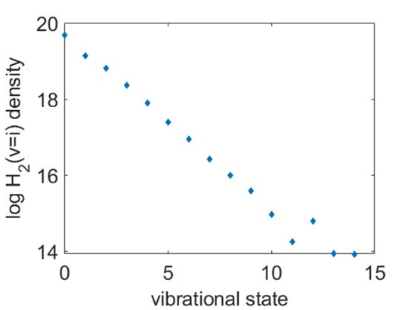

**Figure**: The distribution of vibrational states of H2 in a representative cell outside the plasma beam in the Magnum-PSI target chamber as calculated in a coupled run with solps-iter.

Further progress on simulations of Magnum-PSI and UPP have been obtained within the EUROfusion work package PWIE. A particular improvement of the physical model implemented in solps-iter concerns the rotation of the plasma beam, which is a consequence of the radial profile of the electric potential. By properly taking into account this rotation in the coupling between B2.5 and Eirene, the plasma rotation velocity is imprinted on the CX neutrals [9]. In experiments this rotation is reflected in the Doppler shift of the Balmer-beta spectrum of the hot CX neutral population and can serve as an experimental measure of the radial profile of the potential near the plasma source, which is an essential boundary condition in the solps-iter Modelling of Magnum-PSI and UPP.

**References**

[1] freefem.org (Finite Element Method code)

[2] PW Groen en GF Nallo, draft report_coupling_solps-iter_freefem_v3.docx

[3] G.F. Nallo et al., Journal of Fusion Energy (2023) 42:41

[4] J. Gonzalez et al., Plasma Phys. Control. Fusion 65 (2023) 045009

[5] reference to document with coding rules (eirene repository?)

[6] R. Chandra et al., Plasma Phys. Control. Fusion 63 (2021) 095006

[7] R. Chandra et al., Plasma Phys. Control. Fusion 64 (2022) 015001

[8] J. Gonzalez et al., Plasma Phys. Control. Fusion 64 (2022) 105019

[9] H.J. de Blank et al., (2025) paper in preparation