# 2024 TSVV-5 Annual Report Aalto University, Espoo, Finland

**Development of EIRENE photon tracing model and assessment in JET-ILW L-mode plasmas**

The EIRENE photon tracing model has been applied to the JET-ILW L-mode plasma solutions from SOLPS-ITER to investigate the contribution of Ly-bopacity towards Da emission relative to other processes [Chandra_NME2024]. The model has indicated local regions with high Ly-a and Ly-bopacity in high-recycling and detached conditions. This opacity effect is predicted to reduce the Ly-aand Ly-b signals from the low-field side divertor by at least a factor of 2. The contribution of Ly-b to the population density of D(𝑝 = 3) is mostly localized near the emission source. In the low-recycling regime of JET-ILW divertor, Lyman opacity is negligible. Ly-b is dominant in the high-recycling regime with predicted doubling of Da peak emission values. In the detached regime, contribution from atomic recombination is dominant, but Ly-b capture remains relevant with predicted doubling of Da emission in the private flux region and 50% enhancement at the strike point. In conclusion, opacity effects must be considered for the analysis of Ly-a, Ly-b and Da diagnostics in high-recycling and detached conditions.

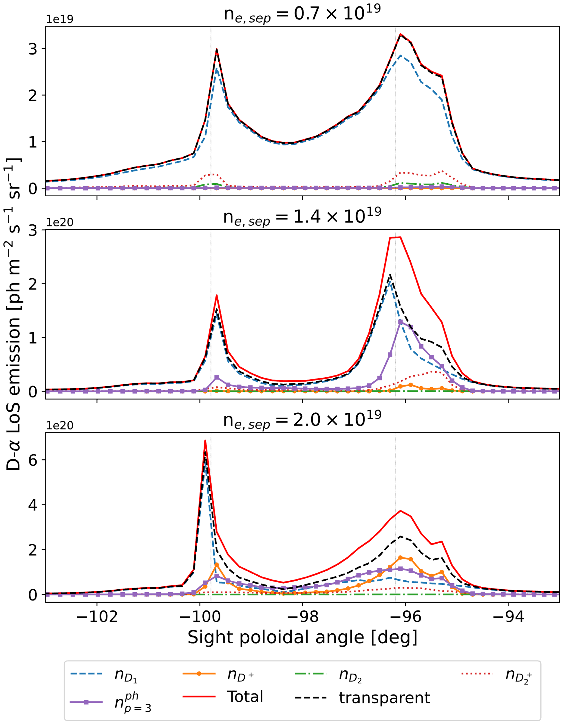

**Figure**: Line-integrated Da emission using KT1 sight lines, separated by contributions from external densities nD1, nD+, nD2, nD2+, and Ly-b absorption nph,p=3 for low-recycling (top), high-recycling (middle) and partially detached (bottom) low-field side divertor conditions. The black dashed line represents total emission without opacity effects. Ly-b absorption contributes a significant fraction of the total line-integrated Da emission at high-recycling and detached regimes.

**Validation of EIRENE gas transport in JET sub-divertor for the hydrogenic isotopes H, D and T**

Standalone EIRENE simulations of gas dynamics of both JET and AUG sub-divertor (with a sealed-off at sub-divertor) exhibits a square root of mass dependence of gas pressure (as anticipated for the hydrogenic gases being in molecular flow). In this project, the gas influx was imposed at sub-divertor entrance from SOLPS-ITER runs [Horsten_NME2024] to speed up the EIRENE simulations. Intermolecular interaction was found negligible at low hydrogenic influx, however important as the influxes were raised and pressures of 1 Pa achieved. The studies showed that the primary louvres create a local pressure gradient between the divertor and the cryogenic pump, while the presence of the secondary louvres increases pump flux (~ 15% reduction in sub-divertor pressure), which is qualitatively consistent with S. Wiesen et al., EPS 2019.

primary

secondary

**Figure**: Molecular pressure distribution (expressed as energy density) of deuterium from EIRENE simulations constrained to the sub-divertor domain.

**Validation of EIRENE predictions of Balmer-a and Balmer-g emission in JET-ILW deuterium L-mode plasmas, role of molecular ion density (D2+)**

The evolution of the EDGE2D-EIRENE predicted Balmer-γ to Balmer-α emission ratio from low-recycling to detached conditions is in qualitative agreement with the measured ratio [Rikala_NME2024]. In the simulations, volume recombination of electrons and the fuel ions is the primary source of the Balmer-γ line emission in detached conditions, thus, the increase in the ratio signifies the presence of volume recombination. Additionally, the EDGE2D-EIRENE predicted emission stagnates in detached conditions with increasing electron density, similarly to experiment, but a factor of 2.5 lower than measured. The discrepancy is partially solved by increasing the core input power in conjunction with the control plasma density.

At the onset of detachment, in the EDGE2D-EIRENE simulations, a D2+ front forms in the far-SOL, which moves towards the strike-point with increasing degree of detachment. The double peak structure caused by D2+ is observed in the experiments, in high-recycling conditions. Simulations with a simplified grid show that the secondary peak is due to the step in the tile-5 to tile-6 transition, since a secondary peak is not observed in the simplified grid. In the simulations, the dissociative recombination of the D2+ ions becomes the dominant source of the Balmer-γ line emission in detached conditions, but there are uncertainties in the calculation of the D2+ density. To accurately assess the impact of the molecular ions D2+ on the Balmer emission, three parameter cross-sections of the charge-exchange process D2 + D+ → D2+ +D, the primary source of D2+, in nD+, TD+, and TD2 is required.

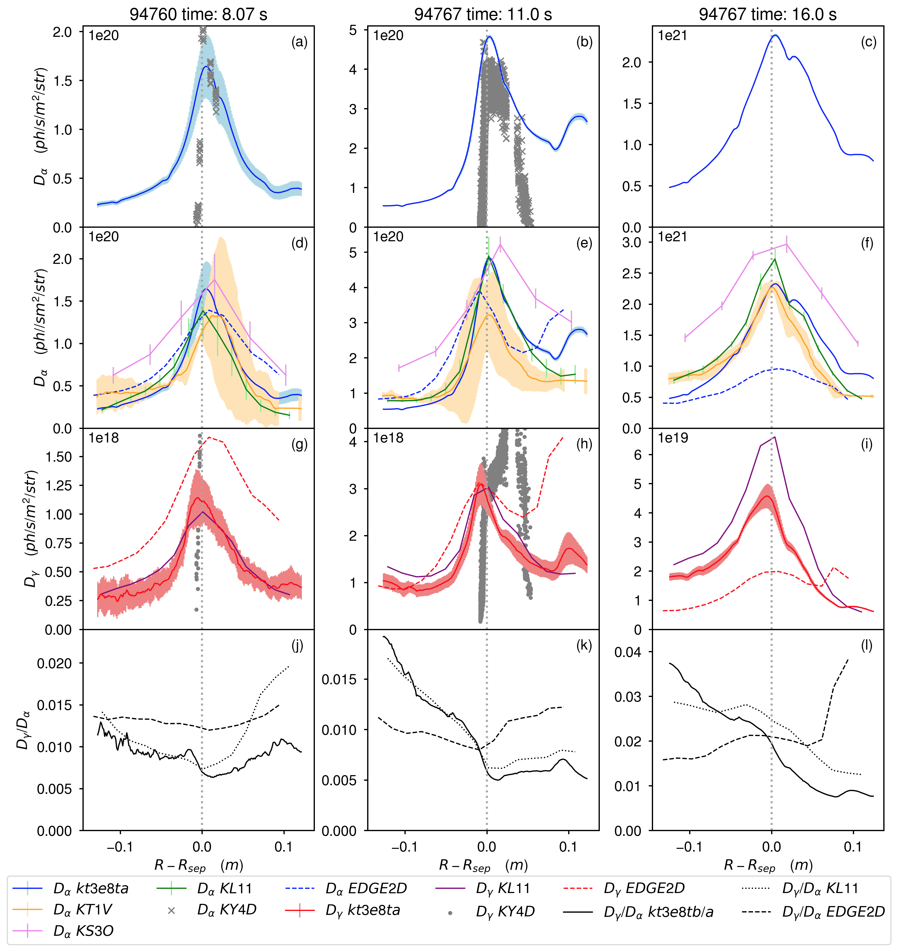

**Figure**: Balmer-α (a-f) line emission measured by kt3e8ta (blue, solid), KT1V (orange), KS3O (purple), and KL11 (green) systems, and Balmer-γ (g-i) line emission measured by kte3e8tb (red, solid), and KL11 (dark purple), on the LFS divertor. The EDGE2DEIRENE predicted Balmer-α (blue, dashed) and Balmer-γ (red, dashed) line emission use the kt3e8ta/b lines-of-sight. The ratio of Balmer-γ to Balmer-α (j-l) is calculated from the kt3e8ta and kte3e8tb (black, solid) and KL11 (black, dotted) measurements, and from the respective EDGE2D-EIRENE predictions (black, dashed). ADAS derived inverse photon efficiency coefficients are used to calculate Balmer-α (gray, x) and Balmer-γ (gray, dot) emissivity from LP measurements of Te and ne (JPN 94759, part of a series of repeat pulses, is used for a and d). The KT1V measurements are shifted to match the peak of the kt3e8ta measurement. The KL11 measurements are from JPN 94771, which is a repeat pulse of JPN 94767.

**References**

[1] R.C. Chandra et al., Nuclear Materials and Energy **41** (2024) 101794.

[2] N. Horsten et al., accepted Nuclear Materials and Energy Dec 2024.

[3] V.-P. Rikala et al., submitted Nuclear Materials and Energy Jun 2024.