IC antenna material definitions for MCNP
(material definition Th. Franke, PMU,
figures F. Zeus, IPP)
Pos. | Part figure (not to scale) | Material description
1 | 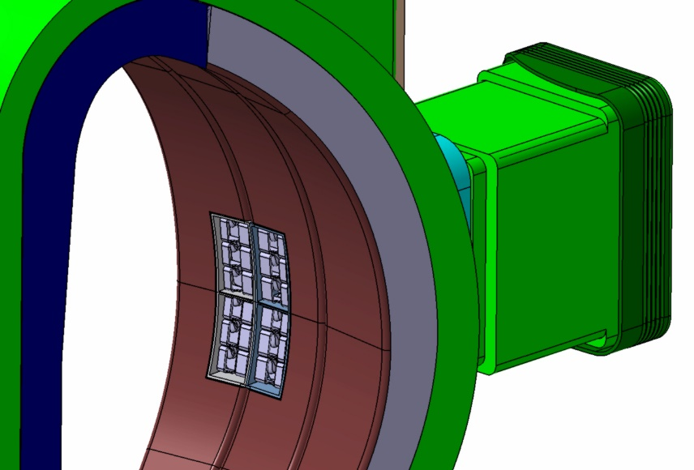 | IC antenna isometric assembly view  Vacuum vessel and port (green), BB first wall (brown), antenna straps (light grey), inboard breeding blanket cross section (dark blue), outboard breeding blanket cross section (dark grey) and optional outer neutron shield (light blue).
2 | 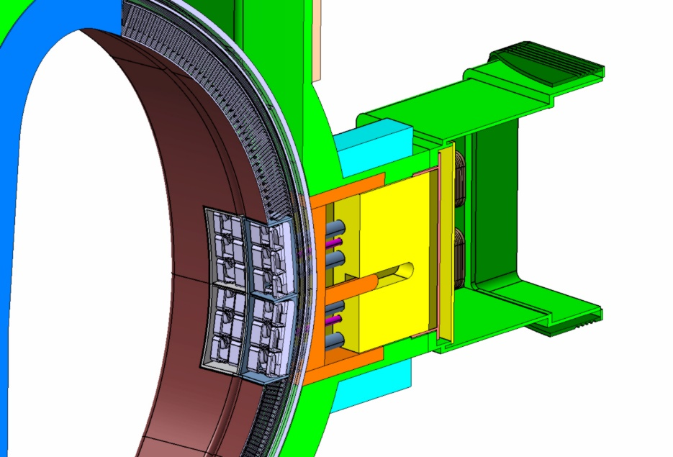 | IC antenna isometric front view, one side open
3 | 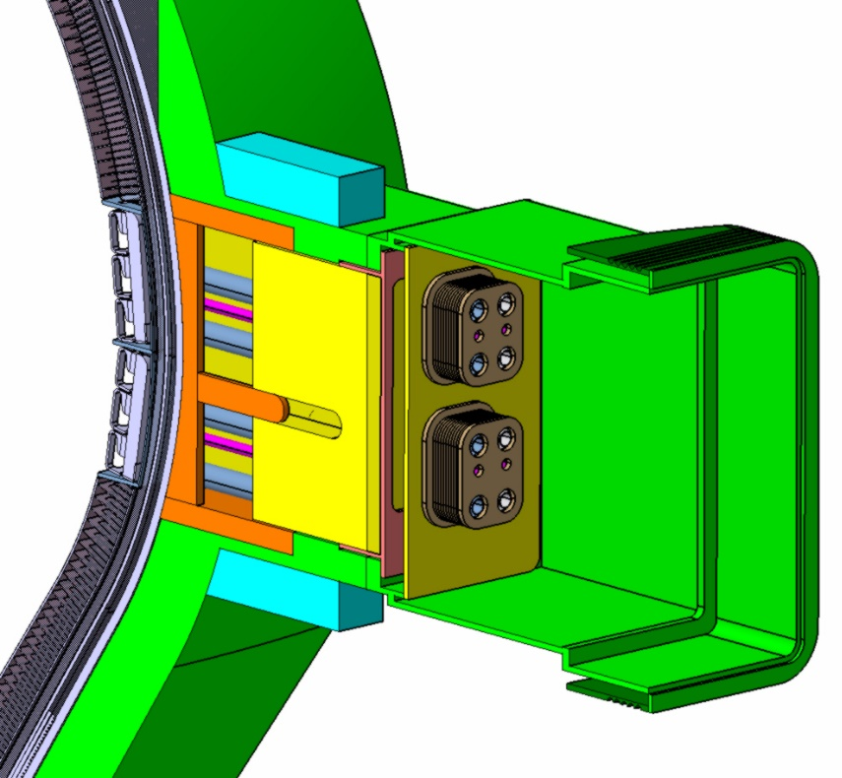 | IC antenna isometric back view, one side open
4 | 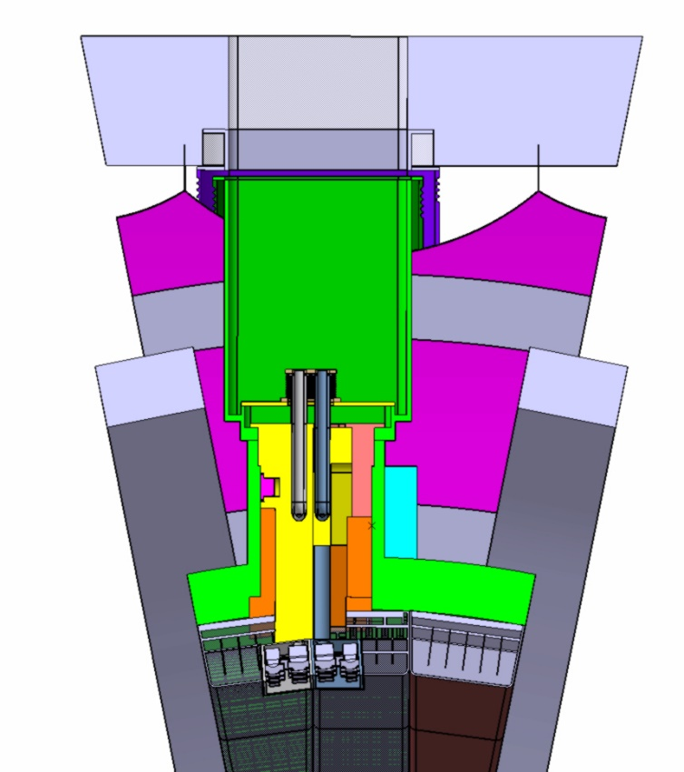 | IC antenna assembly view from top (toroidal cross section)  At right and left side of the port TF coil (grey) behind the port bioshield (light grey), around the port cryostat (magenta).
5 | 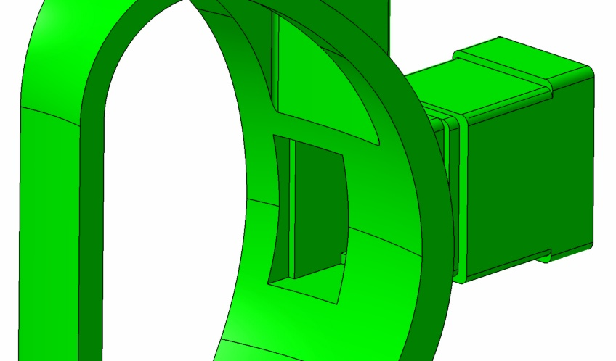  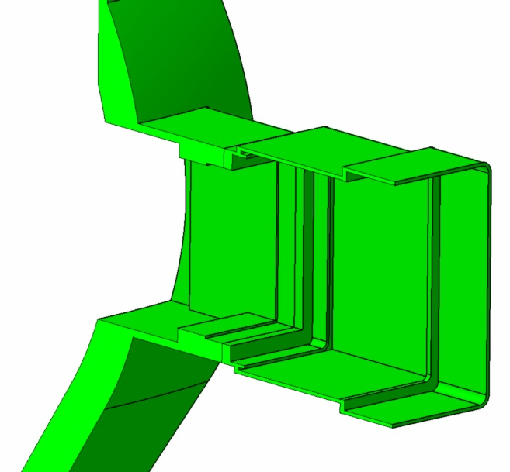 | Vacuum Vessel Port Structure  Stainless Steel 316 LN IG shells filled with mix Stainless Steel / Water mix 60Vol.%/40Vol%,  Front part of port side wall (inside red oval) mix 60Vol.%/40Vol%, other port side walls 100% stainless steel
6 |  | Neutron shields inside the port  Stainless steel 316 LN IG with water mix 60Vol.%/40Vol%,
7 | 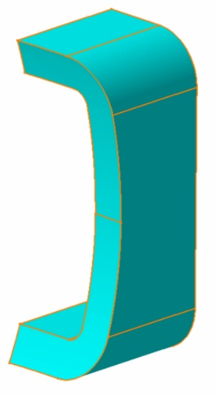 | Neutron shields outside the port  The shield outside the port shall be considered as option (void), and only if needed, but not to be implemented from the beginning in the shielding concept.  Stainless steel 316 LN with water mix 60Vol.%/40Vol%,
8 | 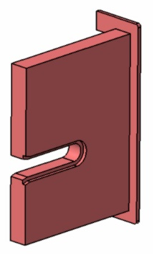 | Neutron shields inside the port (left part).  Stainless steel 316 LN IG with water mix 60Vol.%/40Vol%,
9 | 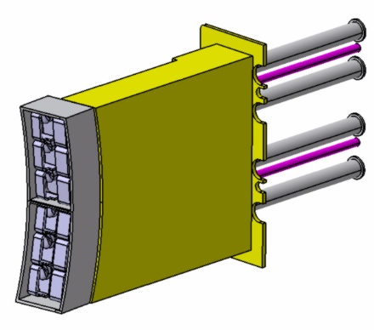 | Right antenna segment (right with reference to former tokamak top view) with straps and box (grey), port plug segment (yellow), water pipes (pink) and coaxial transmission lines (grey)  Port plug segment (yellow)  Stainless steel 316 LN IG with water mix 60Vol.%/40Vol%  Material of antenna straps and box and pipes and transmission lines see below
10 | 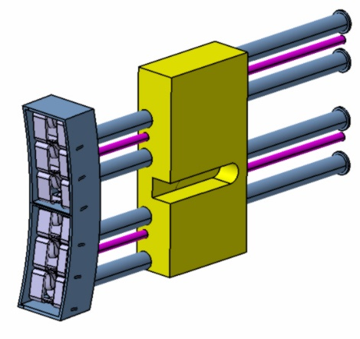 | Left antenna segment (left with reference to former tokamak top view) with straps and box (grey), port plug segment (yellow), water pipes (pink) and coaxial transmission lines (grey)  Port plug segment (yellow)  Stainless steel 316 LN IG with water mix 60Vol.%/40Vol%  Material of antenna straps and box and pipes and transmission lines see below
11 | 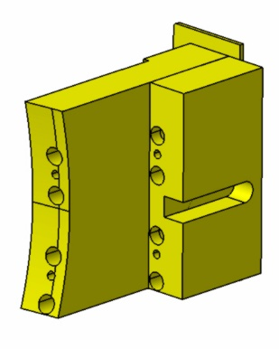 | Middle port plug segment (middle with reference to former tokamak top view) the segment (yellow) is inside the red oval in the figure)  Port plug segment (yellow)  Stainless steel 316 LN IG with water mix 60Vol.%/40Vol%
12 | 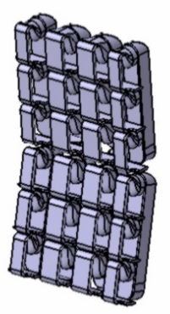 | Antenna straps  Eurofer with water mix 80Vol.%/20Vol%,  (later with a conductive layer, e.g. copper or CuCrZr, not yet considered in the pre-conceptual design)
13 | 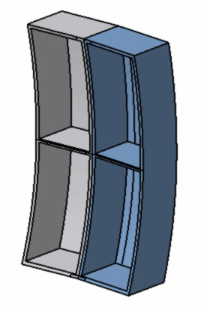 | Antenna box  Eurofer with water mix 80Vol.%/20Vol%,  (later with a conductive layer, e.g. copper or CuCrZr, not yet considered in the pre-conceptual design)
14 |  | Fixations  Stainless steel 316 LN
15 | 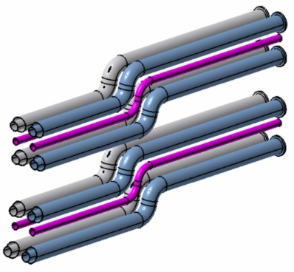 | Coaxial transmission lines and cooling water pipes (assembly view)
16 | 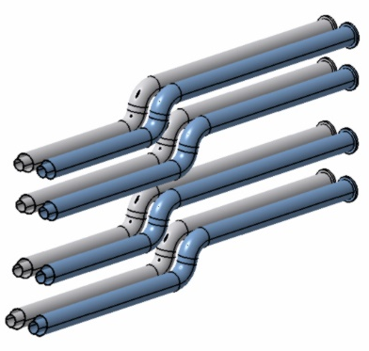 | Coaxial transmission lines  Eurofer for the transmission lines, inside the inner conductor water, between the inner conductor and the outer conductor vacuum  (later with water cooling around, and covered with a conductive layer, e.g. copper or CuCrZr, not yet considered in the pre-conceptual design)
17 | 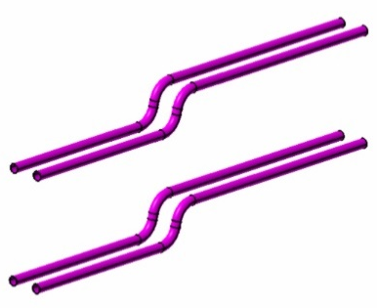 | Cooling water pipes  Eurofer filled with water
18 |  | Vacuum closure plate with feedthroughs assembly view
19 |  | Vacuum closure plate  Stainless steel 316 LN IG
20 |  | Vacuum closure plate feedthroughs  Stainless steel 316 LN IG
21 | 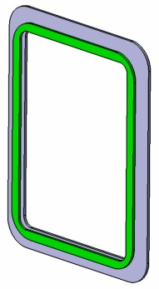 | Cryostat flange  Stainless steel 316 LN IG
22 | 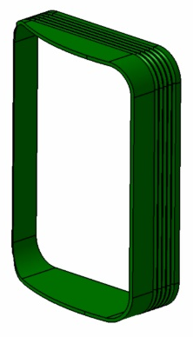 | Cryostat bellow  Stainless steel 316 LN IG
23 | 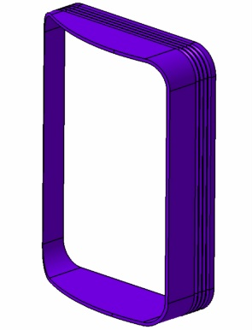 | Bioshield bellow  Stainless steel 316 LN IG
24 | n.a. | Faraday Screen  (To be added in a later state of the design, not yet considered in the pre-conceptual design)

